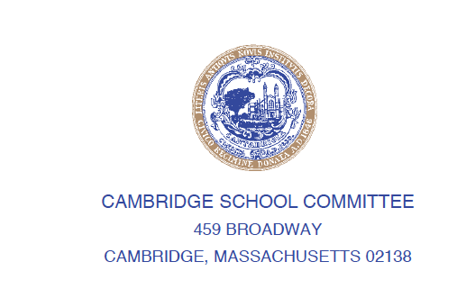

**#25-XXX**

CAROLINE HUNTER

23 Rockwell Street

Cambridge, MA 02139

carhunter@cpsd.us

April 1, 2025

WHEREAS: The School Store, the RSTA School-Based Enterprise at Cambridge Rindge & Latin School, was among 13 school-based enterprises in Massachusetts achieving Gold Level Certification for the 2024-2025 school year; and

WHEREAS:  A school-based enterprise (SBE) is an entrepreneurial operation in a school setting that provides goods and services to meet the needs of the market. SBEs are managed and operated by students as hands-on learning laboratories that integrate National Curriculum Standards in marketing, finance, hospitality and management. SBEs have been an effective educational tool for over four decades, providing students with realistic and practical learning experiences that reinforce classroom instruction, enhance 21st Century skill development, and prepare students for college and careers; and

WHEREAS: The School Store at Cambridge Rindge & Latin School has operated for 11 years and is to be commended for this achievement. Mrs. Jacqui Cesario is in her 6th year teaching Business Education and running the School Store and her 30th year teaching at CRLS; and

WHEREAS: In 2023, Mrs. Cesario and Ms. Jennifer Sloan Green started a DECA Chapter at CRLS as part of the Business Club which sponsors an annual Financial Literacy Fair. This year the DECA Chapter had 8 students compete in the district program and 6 students participated in the SBE certification; and

WHEREAS: Christopher Young, CAE, Chief Program Officer at DECA Inc., states “DECA’s School-based Enterprise Certification Program is a rigorous process designed to help DECA members demonstrate their classroom learning in a practical, learning laboratory, and then translate that into meaningful outcomes.”; and

WHEREAS: DECA’s school-based Enterprise Certification Program provides recognition for outstanding achievement by school-based enterprises and motivates SBEs to strive for excellence and growth. SBEs can be certified at three levels: bronze, silver or gold. In order to apply for the certification, SBEs must submit extensive documentation that explains how the SBE demonstrates the practice of various marketing and retail standards; now therefore be it

RESOLVED: That he following CRLS DECA members are acknowledged and commended for their contributions to the certification application and process: Youseff Adel, Jalyjah Davis, Sebastian Dumoulin, Sophya Gedeon, Sulav Ghimire and Kaleb Woldemeskel; and be it further

RESOLVED: ThatCambridge Rindge & Latin School DECA will be recognized as an Outstanding School-based Enterprise (SBE) at DECA’s International Career Development Conference this April 26-29, 2025 in Orlando, Florida; and be it further

RESOLVED:That the entire Cambridge School Committee congratulates the RSTA CRLS DECA Chapter and advisors Mrs. Jacqui Cesario and Ms. Jennifer Sloan Green, for its Achievement of Gold Level Certification and its recognition at the 2025 National DECA Conference.